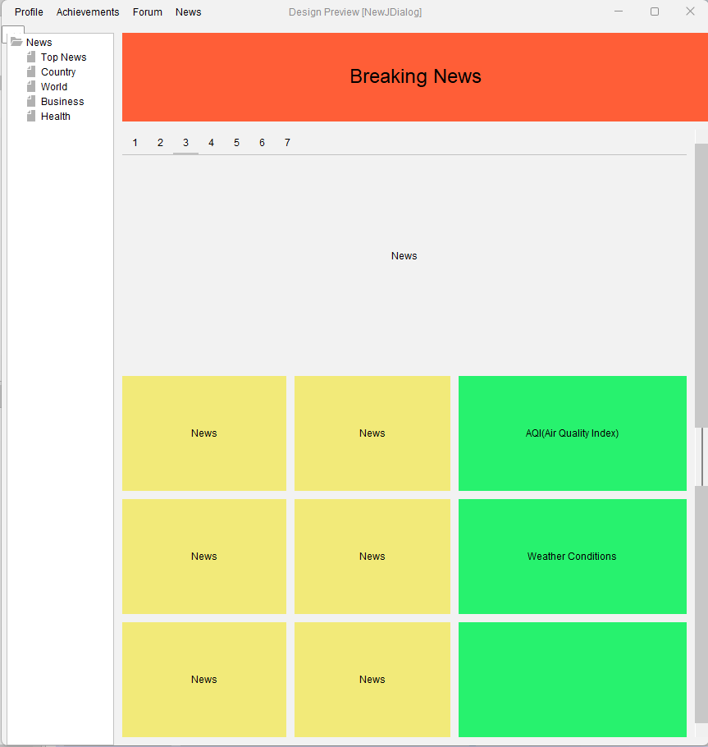

In the news tab of the application, user will be able to see news about the topic. On the top of the page, there will be “Breaking News” panel and user will see the most important news. Under “Breaking News”, important and featured news will be listed, and the user will be able to switch to other news from the tabs above. Although it is currently set to switch between 7 news, we will increase the number of news that can be switched in this panel. On the left of the page, there will be news categories that can be selected by the user. Although these have been determined as "Top News, Country, World, Business, Health" for now, they will be added in different categories in the final version of the application. There will be 2 sections at the bottom of the page. The first of these will be the section with daily news.

The news in this section will consist of more casual content than the news at the top of the page. In the second part, there will be a panel showing the air quality of the user's location. Below that, there will be another panel showing the weather conditions of the user's location. The locations of these panels can be changed by the user. At the bottom, there will be a separate panel where the content can be personalized by the user. In addition, the user will be able to set how many news and indicators will be found in this section.